**Ideation Phase**

**Brainstorm & Idea Prioritization Template**

|  |  |
| --- | --- |
| Date | 27 September 2022 |
| Team ID | PNT2022TMID51170 |
| Project Name | Project - Inventory Management System for Retailers |
| Maximum Marks | 4 Marks |

**Step-1: Team Gathering, Collaboration and Select the Problem Statement**

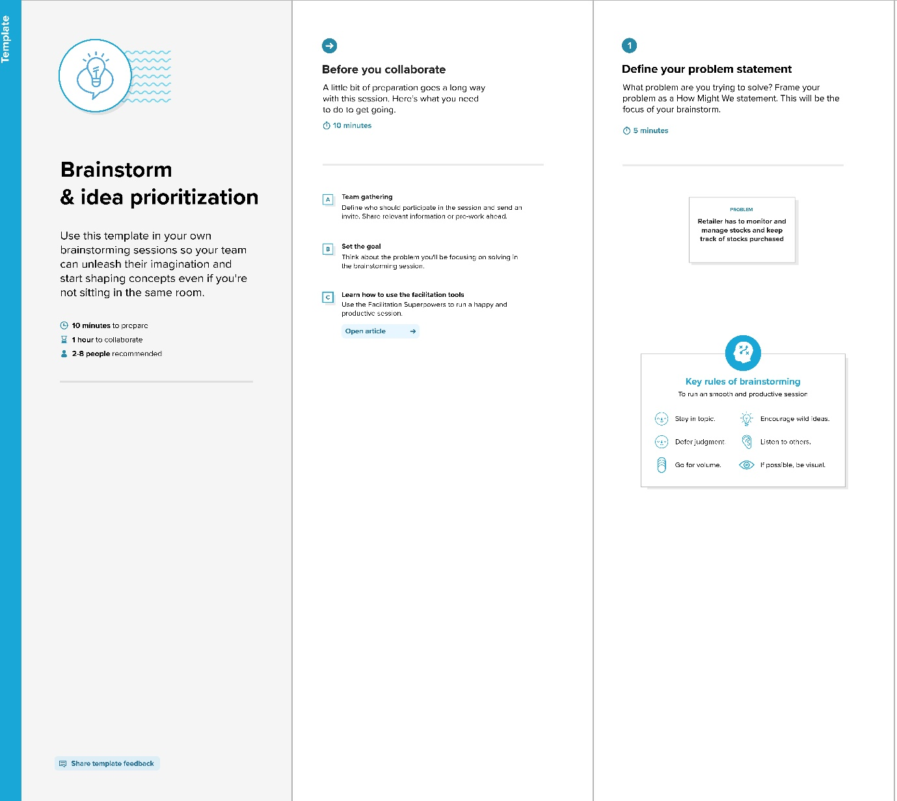

**Step-2: Brainstorm, Idea Listing and Grouping**

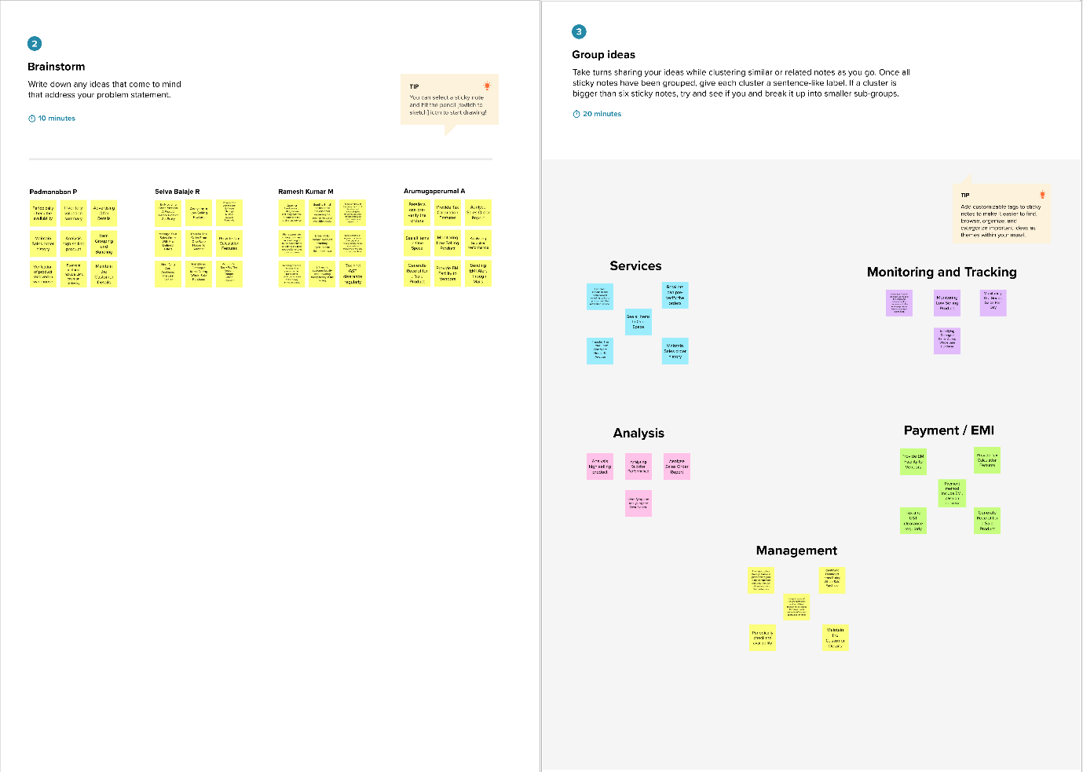

**Step-3: Idea Prioritization**

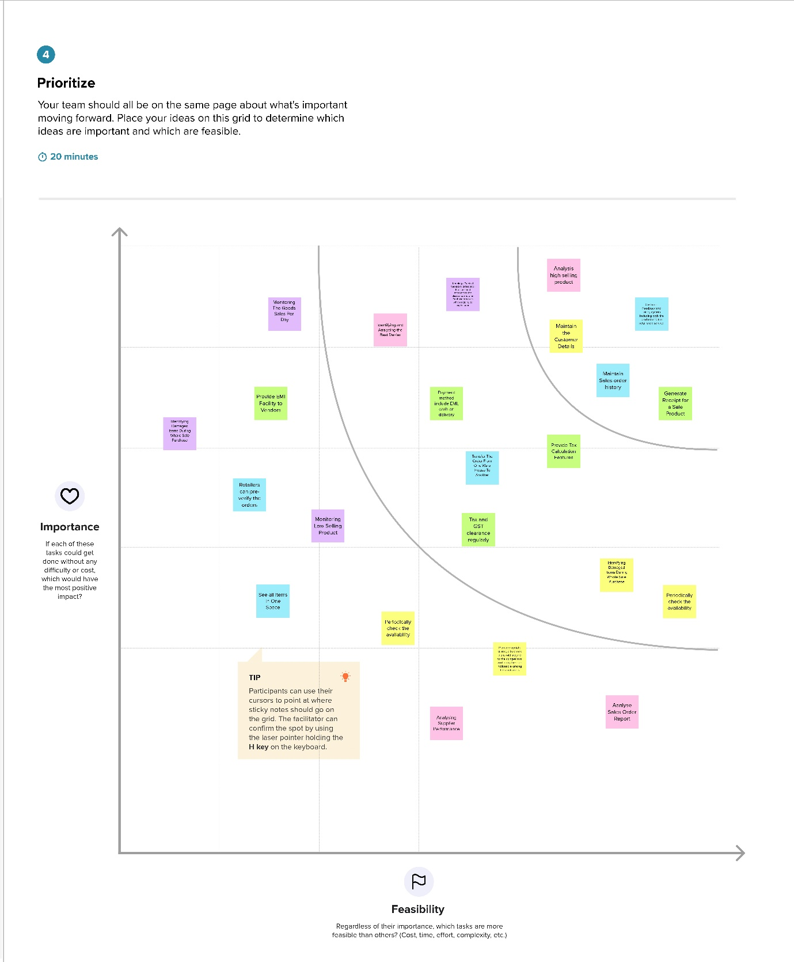

Reference: <https://app.mural.co/t/ibmimsworkspace7657/m/ibmimsworkspace7657/1664297490983/74181eff6a5c477be447605df450d6a324bfb07e?sender=u0dac037e3afef78aa6713615>